Kaitaia Publishing Collective

Haris Khan, Konan Kouame, Ryan Horwitz, Christopher Luzzi, Benjamin Jackson

CSC 3710 Methods Systems Analysis - Fitchburg State University

# Information

First page: : Cost-Benefit Analysis - Konan Kouame

Second page: Project Size - Haris Khan

Third page: Staff Estimate - Benjamin Jackson

Fourth page: Risk Analysis - Ryan Horwitz

Fifth page : Project Recommendations - Christopher Luzzi

**Cost-Benefit Analysis (From Milestone 1)**

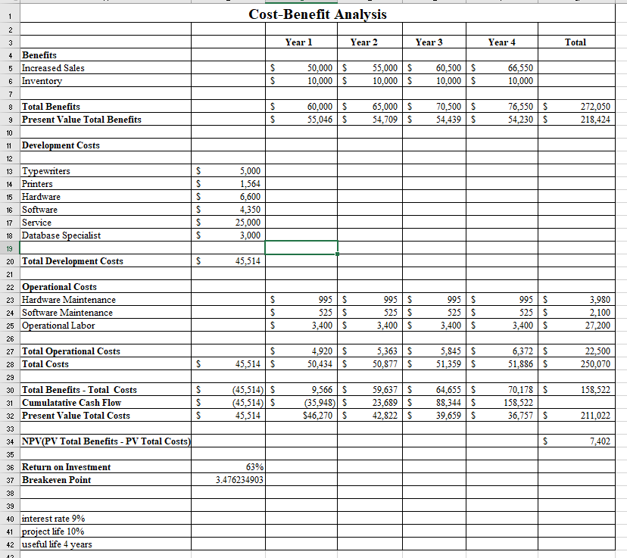

ROI = 63%

Break-even point = 3 + (70,178- 36,757)/ 70,178

Break-even point = 3.47 years

Cost Analysis (updated)

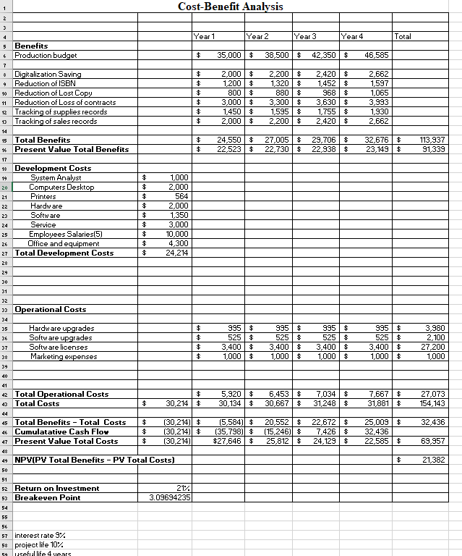



ROI = 21 %

Break-even point = 3 + ( $25,009 + $22,585)/ $25,009

Break-even point = 3.09 years

**Project Size**

**Scope**

The size of this project is very large because we are implementing a system to assist with error correction and database management of Kaitaia Publishing collectives assets. We will be configuring a database for Kaitaia to maintain and record ISBN numbers for books, documentations and works by authors, financial transactions, and other related information that Kaitaia needs to keep record of and manage. This project will completely change the way Kaitaia Publishing manages their assets and how they keep records. It is a significant and important change that will benefit the company in numerous ways.

**Purpose**

The system we are going to create will serve as a large stepping stone in Kaitaia Publishings growth as a company. There are many detrimental factors of continuing with the same business strategy they are currently functioning with. The purpose of our system is to organize and structure Kaitaia’s records and this will be done through a database.

**Size and Length of Project**

Our project will be relatively small and consist of 7 technicians that will assist with designing, implementing, and maintaining the new system. Our system can range anywhere from 4 months to 4+ years to complete. We will have three systems analysts, two computer technicians, two database analysts, and a technology trainer. Our systems analysts will review documentation and company needs to determine what systems need to be implemented and why. This process will take 4 years to complete because we need to analyze Kaitaia’s current system and documentation. The database itself will take 3 months to 4 years to create and maintain because we need to sort through previous documentation and records and incorporate them within the database. The technology trainers will hold courses for the employees at Kaitaia to inform and instruct them on how to use the new system. This estimated time for completion for this will depend on the availability of the employees and will be completed within the first year of the implementation of this project.



**Cost**

The total cost for this project will roughly be around $154k-$155k for all four years. This is all displayed on our cost-benefit analysis sheet. The benefits of this project far outweigh the cost and will prove useful to Kaitaia.

**Estimated Staff**

Since this project is relatively small in size and scope, there will only be a need for a small amount of staff in order to complete the project. We plan on having nine employees working on this project in total, two of which will be existing Kaitaia Publishing Collective employees, and our five Software Unlimited employees. This will help to keep the overall cost of the project down, instead of hiring new employees. By utilizing existing Collective employees, it will also ensure that Kaitaia Publishing Collective will be able to better manage their system, since they will be directly involved in the development of the new system.

Two database analysts should be enough to handle Kaitaia Publishing Collective’s new system, since their role will be to ensure that all entries made to the system are correct, and that the system is working properly. The hopes are that an existing Kaitaia Publishing Collective employee who has the technical skills necessary to learn how to manage the database could work alongside one of our Software Unlimited employees. After the project is completed, we’d like that Kaitaia Publishing Collective employee to be able to train another Collective employee to work alongside them, since our SoftwareUnlimited employee will only be there for the length of the project. These two employees should have good communication skills, as well as basic computer skills, and the willingness to learn about the database software/hardware such as Windows Server.



We will also need to hire a Technology Trainer in order to train the Collective’s employees to use the new system, and it’s software. They will only be around for the first year, with the hope being that any potential newcomers to the Collective’s staff will be able to learn the system through the existing employees. This person should be knowledgeable in the hardware and software that we are utilizing, as well as having the communication skills necessary to train the employees.

Two computer technicians will be outsourced in order to ensure that there will always be someone around in the case that there is an issue with the system. Outsourcing will help to keep the costs down, since hiring two employees could negatively impact the budget for the project. The company that we outsource from should, ideally, be specialized in dealing with small businesses.

Finally, the other four of our Software Unlimited employees will act as network engineers in order to put the system together. This will involve the planning, designing, and construction of the new system. They will need to have the communication skills necessary to discuss the system with Kaitaia Publishing Collective management in a way that can be easily understood. They will also need to be able to think logistically in order to plan the construction of the system to fit within a realistic, and affordable time frame.

**Risk Analysis**

There are a few risks that will be faced throughout this project. The main risk we will face is the size of the project. This project is small and it will not require an abundant amount of time for work and will also only require only a decent amount of employees to be hired for the process of the project to be completed.



**Implementation**

The implementation part of this project is a key risk factor because if an implementation of one of the steps goes wrong it could cost the project heavily. There are detailed explanations of the production schedule that shows how much each part of the project should be spent, time wise. If any of these steps were to take possibly a week more than expected, it will push everything back and make the rest of the project implementation much more difficult since employees will be rushing to complete the project on time.

**Operation/Development Costs**

The operation/development cost is a risk to the project considering there is a possibility that it increases. This is due to our original estimate that is on the Memo and Cost Benefit sheet, these amounts that are recorded are estimated of what something may cost throughout the process of the project. Any of these amounts are subject to change during the project and could possibly cause concern if the amount is higher than can be dealt with.

**Benefit Amount**

The benefits amount is also a situation that has risks. As stated prior, the amounts that are recorded on the Cost benefit sheet are estimated of what the company should receive. They are subject to increase and decrease depending on many variables that can and can not be controlled.

**Staffing**

The staff in the project are a risk due to the possibility of two reasons. The first would be that an employee does not do their job efficiently to the point of being acceptable. The second is that if an employee is not able to do their job in an unforeseen circumstance. Both these situations may require having to hire someone throughout the process of the project thus will slow down the project since it is now needed to wait for an employee to be hired and then having to catch the employee up to the point of where the project is at.

**Hardware/Software**

There is a possibility that part of the hardware and software that project relies on could cause an error to delay the outcome of the project. This could even include possible network downtime that is out of the projects control.